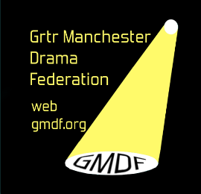
GREATER MANCHESTER DRAMA FEDERATION
registered charity no. 517020 www.gmdf.org
The 78th Annual General Meeting Will Be Held On
Wednesday 30th August 2023 8pm at
Altrincham Little Theatre, Oxford Road, Altrincham. WA14 2ED

Notice is hereby given to all members in respect of the GMDF 78th Annual General Meeting to be held as stated above.
Your Board of Management hope that as many members as possible will attend the meeting to transact the business on the agenda below. If you have any ideas or suggestions you wish to be discussed, please let the Federation Secretary have these prior to 20th August 2023. This is your Federation and your participation is required and will be welcome so please let your society be represented.

Please note that in accordance with the Constitution only one representative per Society may vote on any issues that may arise.
In accordance with the rules of the Federation, all Officers and three of the elected Board Members retire but are eligible for re-election unless otherwise indicated.
We have vacancies on the Board so we ask you to seriously consider anyone in your Society who may wish to join us. If you or anyone you know would like further information about joining us please contact us.

Please complete the enclosed slip for your nominations and return it to:
Hon Secretary, Mrs B Harris, 94 Brown Lane, Heald Green, Stockport. SK8 3RA to arrive by 20th August 2023, please also, bring this agenda with you to the Annual General Meeting.

A G E N D A

- Apologies for absence
- Minutes of 77th Annual General Meeting
- Matters Arising
- Correspondence
- Chairman’s Report
- Hon. Treasurer’s Report and adoption of the accounts for 2022 - 23
- Election of Officers and Board Members 2023 – 2024
- Membership Fees
- Full Length Play Festival inc entry fees and Adjudicators
- One Act Play Festival
- GMDF Directory
- Any Other Business

